Name: DAYAL ADITYA KISHOR

Class: FYMCA

Div: B

Roll No.:18

**Assignment 11­**

**1)**

create or replace trigger R1

before insert

on ord_dtl

for each row

begin

update prod_mst set booked_qty = booked_qty + :NEW.qty where prod_cd = :NEW.prod_cd;

end;

/

Output:

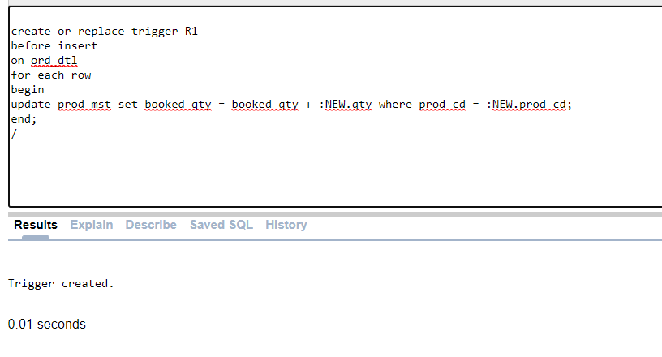

**2)**

create or replace trigger t1

before delete

on emp1

for each row

begin

insert into audit1 values (:OLD.emp_id, :OLD.ename , SYSDATE,'Delete');

end;

/

create or replace trigger t2

before update

on emp1

for each row

begin

insert into audit1 values (:OLD.emp_id, :OLD.ename , SYSDATE,'Update');

end;

/

Output:

